|  |  |
| --- | --- |
| DEPARTMENT OF MECHANICAL ENGINEERING  INDIAN INSTITUTE OF TECHNOLOGY ROPAR  RUPNAGAR-140001, INDIA | **IIT Ropar**E:\departmental work\2012.07.20-IITRPR-LOGO\2012.07.20-IITRPR-LOGO\2012.07.20-IITRPR-NEW LOGO.jpg |

*B-Tech Project Report*

*On*

*Miniature thermal power plant*

Submitted By

Ajay Yadav (2016meb1145@iitrpr.ac.in)

Himanshu (2016meb1121@iitrpr.ac.in)

Supervised By

Dr. Chander Shekhar Sharma

Table of Contents

**Abstract** 3

**Notation** 3

**Introduction** 4

**Theory of Film and Drop wise condensation** 5

**Wettability, non-wettability and contact angle hysteresis.** 6

**Review of other Setups** 9

Schematic diagram of setup 10

Components required to make Setup: 11

Condensation Chamber Design and Dimension 12

Dimensioning of the Teflon block 14

Copper Block 15

Copper block dimensioning 19

Circular clamp 20

Dimensioning of Circular ring 20

Plexiglass (front cover) 21

Dimension of Plexi Glass 21

Back cover 22

Dimension of Back cover 23

Stand 24

Orings 25

Model 25

Products used 28

**Steam Thermodynamics** 30

**References** 32

# 

# **Abstract**

To increase the effectiveness of condensers used in powerplants and consequently the overall powerplant, by enhancing dropwise condensation, hydrophobic surface coatings can be used. In this project we have designed an experimental setup, a miniature powerplant like setup that will be used for quantifying the heat flux associated with hydrophobic and hydrophilic surfaces under study. Required theory to understand the experimental process is given below. Overview of the setup with its justification on the choice of component and the materials used has been given.

Keywords: - Drop wise Condensation, film wise condensation, heat flux

# **Notation**

S= Surface tension

θ= Angle between the tangent of the liquid surface and solid surface

Tw = Turbine work

ṁ= mass flow rate

h=enthalpy

S= Spreading factor

E= surface energy per unit area

γ= interface tension

# **Introduction**

This project can be useful in surface condenser applications where a change in the nature of surface can lead to improved functioning. A main application of such surface condenser is in thermal power plants in steam condensation.

Generally thermal power plants work on Rankine cycle. And a typical Rankine cycle’s Temperature-entropy diagram looks like figure 1[1] which gives the turbine work.

Tw=ṁ(h2-h3) (1)

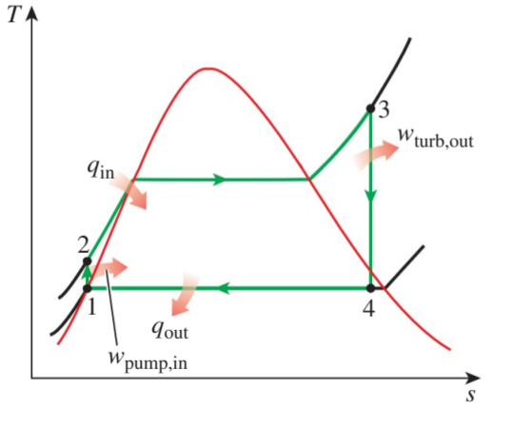

*Figure 1 Rankine cycle*

To increase the turbine work output, enthalpy of state 4 can be reduced, which can be achieved by reducing the temperature of state 4 and thereby reducing the corresponding pressure. (As temperature and pressure are each other's function during the phase change process.) The experiments that will be further performed using this setup will be under conditions of low pressure in the range of (10-50mbar).

# **Theory of Film and Drop wise condensation**

In film wise condensation, the condensate wets the surface forming a liquid film of increasing thickness from top to bottom that slides down under the influence of gravity. This “liquid wall” between solid surface and the vapour serves as a resistance to heat transfer. The thickness of the liquid film increases in the flow direction as more vapour condenses on the film.

In Drop wise condensation, the condensed vapour forms droplet on the surface instead of a continuous film, and the surface is covered by countless droplet of varying diameters. As the drops grow in size their weight leads them to shed leaving the surface expose to steam.

**Why drop wise condensation is better?**

The Heat Flux in dropwise condensation is more than in film wise condensation. This can be explained in terms of how the condensation forms on the condenser. The vapour drops in dropwise condensation are discrete and are continually formed and released which means that the surface of the condenser is also continually exposed. In comparison, the film created in film wise condensation always covers the surface of the condenser. This film creates an additional thermal resistance which is the reason why the value for Heat Flux is lower for film wise in comparison to dropwise condensation[2].

Lower heat flux means the net heat transfer rate will be less for film wise condensation for a given surface area. Thus, the net rate of condensation will be more for drop wise condensation.

# **Wettability, non-wettability and contact angle hysteresis.**

When a drop is placed on a very clean glass, it spreads completely. By contrast, the same drop deposited on a sheet of plastic remains stuck in its place. The conclusion is that there exist two regimes of wetting[3].

Wetting can be characterized into two types:

1. Total wetting: when the liquid has a strong affinity for the solid; and
2. Partial wetting: the opposite case.

**Spreading Parameter**

Spreading parameter, S distinguishes the two different regimes of wetting. It measures the difference between the surface energy (per unit area) of the substrate when dry and wet:

S = [Esubstrate]dry - Esubstrate] wet or S = γsolid - (γliquid + γsolid-liquid)

**S > 0: Total wetting**

If the parameter S is positive, the liquid spreads completely in order to lower its surface energy. A high value of γsolid (high energy surfaces like glass, clean silicon) and a lower value of γliquid (ethanol, toluene) ensures total wetting

**S < 0: Partial wetting**

The drop does not spread but, instead, forms at equilibrium a spherical cap resting on the substrate with a contact angle θ. A liquid is said to be "mostly wetting" when θ < 90°, and "mostly non-wetting" when θ > 90°.

**Partially wetting and partially non-wetting**

When the solid has a high affinity for water - in which case it is called hydrophilic (high energy e.g. glass)- water spreads. In the opposite case of hydrophobic (low energy e.g. Teflon) surfaces, water does not spread but, instead, forms at equilibrium a spherical cap resting on the substrate with a '*contact angle*'.

**Young's equation for contact angle**

1. The first method consists in tallying up the capillary forces acting on the line of contact (also called triple line) and equating the sum to zero. When normalized to a unit length, these forces are the interface tensions between the three phases (S/L/G). By projecting the equilibrium forces on the solid plane, one obtains the Young' relation.

γsl - γs + γlv cos θ = 0 or cos θ = (γs - γsl )/ γlv

It is evident that θ can be defined only if the spreading parameter is negative. θ increases when the liquid is non-wetting.

It is evident that θ can be defined only if the spreading parameter is negative. θ increases when the liquid is non-wetting.

1. The second method relies on calculating the work done by moving the line of contact by a distance dx:

dW = γsl.dA - γs.dA + γlv.dA.cos θ

At equilibrium, dW/dA = 0, which leads to the same equation as above.

The following figure 2 shows hydrophobic and hydrophilic surfaces and their contact angles.

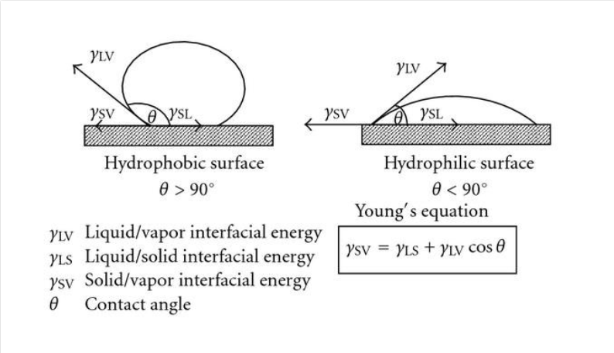

*Figure 2 Hydrophobic and Hydrophilic surfaces[4]*

**Contact angle hysteresis: advancing Vs receding contact angle**

Contact angle measured for a liquid advancing across a surface exceeds that of one receding from the surface. Contact angle is generally attributed to surface roughness, surface heterogeneity, solution impurities adsorbing on the surface, or swelling. Advancing contact angle (θA < θR) is always larger than or equal to the receding contact angle. The difference between the two is called contact angle hysteresis.

If we measure the contact angle while the volume of the drop is increasing - practically this is done just before the wetting line starts to advance-we get the so-called advancing contact angle θA. If we afterwards decrease the volume of the drop and determine the contact angle just before the wetting line is receding, we measure the so-called receding contact angle, θR. Usually θA is significantly higher than θR. The difference θA - θR is called contact angle hysteresis.

**Hydrophobic and hydrophilic surfaces**

In the water molecule, the hydrogen atoms tend to have a slightly positive charge and the oxygen atoms a slightly negative charge. Water molecules cling to each other through the hydrogen bond. No polar molecules form hydrogen bonds, so in the presence of water, the nonpolar molecules associate with one another while excluding the water molecules. This minimizes the overall free energy of the system. Nonpolar molecules that repel the water molecules are said to be hydrophobic and polar molecules forming ionic or a hydrogen bond with the water molecule are said to be hydrophilic.

Water is repelled more by a surface when the hydrophobicity of the surface is increased. The contact angle of a water droplet is larger on a more hydrophobic surface.

Hydrophobic interaction plays critical roles in the formation of the lipid bilayer of the cell membrane and the folding of proteins and nucleic acids; therefore, hydrophobic interaction is the foundation for the existence of life.

A self-assembled monolayer (SAM) is a layer of organic molecules formed spontaneously on a solid substrate. One end of the organic molecule binds to the solid surface via a covalent bond while the other end points outwards. One of the many ways to form SAMs on different solid substrates is to use thiol-containing organic molecules to form a packed SAM on coinage metals such as gold, silver, copper. Because the exposed end of the SAM determines the surface properties of the SAM modified substrate, we can alter a hydrophobic surface (a surface that expels water) into a hydrophilic surface (a surface that attracts water) by carefully selecting the SAM forming molecules.

A fluid will stick to a solid surface if the surface energy between fluid and the solid is smaller than the sum of surface energies between solid-air, and fluid-air.

The surface of liquid near the plane of contact, with another medium is in general curved. The angle between tangent to the liquid surface at the point of contact and solid surface inside the liquid is termed as angle of contact. It is denoted by θ. It is different at interfaces of different pairs of liquids and solids. The value of θ determines whether a liquid will spread on the surface of a solid or it will form droplets on it[5].

# **Review of other Setups**

We looked at two previous studies:

1. Paxson, Adam. “Condensation heat transfer on nanoengineered surfaces”. Master’s thesis. Massachusetts Institute of Technology, Massachusetts, USA. 2011[6].
2. Emmerich, Theo. “Design of an experimental setup for the observation of condensation at low pressure”. Semester Project. ETH Zurich, Zurich, Switzerland. 2016 [7].

Similar setups for studying condensation were used in the above-mentioned studies. A copper block was used to provide the cooling flux and was also outfitted with thermocouples at regularly spaced axial distances. The copper block was kept in an insulated chamber where saturated steam condensed on the surface under study. Temperatures and pressures were monitored in the chamber and the surface was examined using a camera.

In study 1, we looked into ‘study of macroscale condensation heat transfer’. In this experiment critical dimensions of the apparatus were decided by the size of sample surface. A careful balance of heat transfer paths was ensured to maximize the heat flux through the sample, cooling block and reduce the heat flux to the chamber and the environment. A steam separator and steam trap were installed upstream of the condensation chamber to ensure that only saturated steam reaches the chamber. A moisture trap was used to regulate the steam flowing into the condensation chamber. Heat flux through the copper block was measured by a series a of 4 thermocouples embedded into the copper block along the centreline. The surface temperature was extrapolated via the overall thermal resistance. At the beginning precautions were taken to ensure an absolute minimum of non –condensable entered the chamber. Oxygen gas sensor was used to measure the oxygen concentration in the condensation chamber. Constant pressure was maintained inside the chamber and heat transfer due to condensation was allowed to reach a steady state. During steady state high resolution videos were recorded with a digital camera.

In study 1, the effect of the non-condensable on the condensation process was not confirmed. To investigate the effect of vapour velocity it will be necessary to regulate the mass flow through the auxiliary condenser with an electronically controlled actuator, instead of a manual ball valve as was used in these experiments. The initial results of this apparatus demonstrated its potential, but a large amount of work is yet to be done.

In study 2 the condensation chamber was designed with extreme care to reduce the distance between the sample and the outside walls as well as the leakage to limit the quantity of non-condensable gas inside the chamber.

In study 2 the following issues for measuring the temperature at the sample’s surface were discovered: the sensor at the back of the sample does not respond when under pressure between the sample and the copper cooler. In order to measure the heat transfer coefficient, a solution for measuring the temperature at the surface of the sample is needed. Alternatively, the estimation of the thermal resistance between the sample’s surface and the first sensor in the cooler can be measured. Then knowing the heat flux and the temperature at the first cooler sensor, the sample’s surface temperature can be estimated.

**Setup Overview**

## Schematic diagram of setup

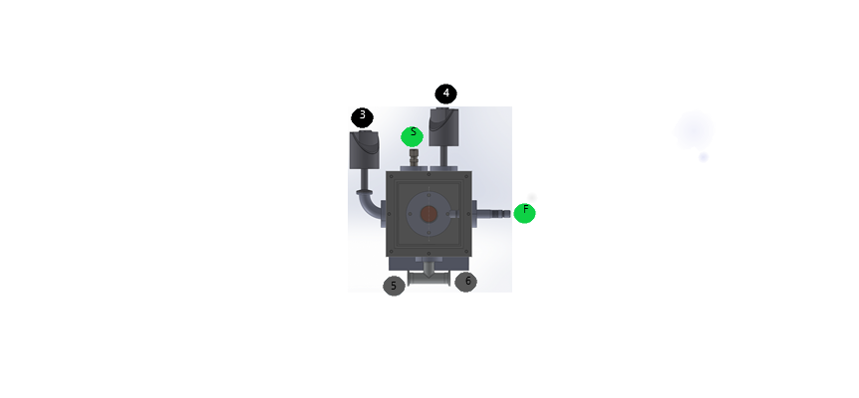

Condensation chamber

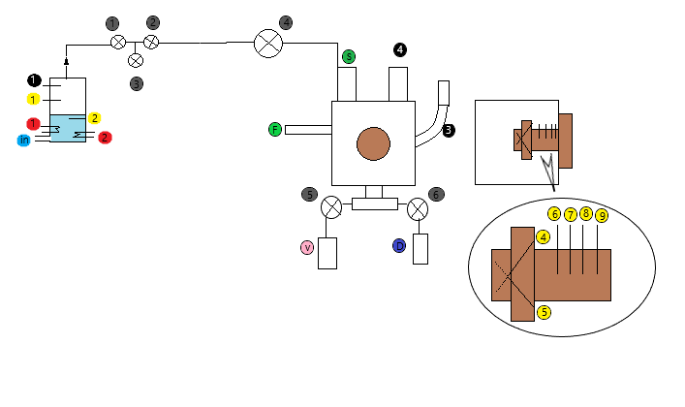

Condensation chamber

Copper block

Electric boiler

*Figure 3 setup overview*

## Components required to make Setup:

1. Pump
2. Boiler (consists of)

|  |  |
| --- | --- |
| 1. | 1st 2KW Heater |
| 2. | 2nd 2KW heater |
| 1. | 1st temperature sensor (to sense water vapour temperature) |
| 2. | 2nd temperature sensor (to sense water temperature) |
| 1. | 1st pressure sensor (to sense water vapour pressure) |
|  | Water level indicator |

1. Valves

|  |  |
| --- | --- |
| 1. | Steam Shutoff Valve |
| 2. | Steam Outlet Valve |
| 3. | Steam Drain Valve |
| 4. | Pressure Reduction Valve |
| 5. | Shuttle Valve (Vacuum Pump) |
| 6. | Shuttle Valve (Water Drain) |

1. Condensation chamber made up of PTFE block (consists of)

|  |  |
| --- | --- |
| P. | Plexi Glass (Transparent sheet to observe condensation process) |
| C. | Clamp (to hold the substrate) |
| S. | Steam inlet valve |
| F. | Vacuum feed through (for temperature sensors) |
| 3. | High range Pressure sensor |
| 4. | low range Pressure sensor |
| C. | Copper block (through it heat transfer will occur) |

1. Copper block contains

|  |  |
| --- | --- |
| 4. 5. | Thermocouples at 550 (to measure surface temperature) |
| 6. | RTD to measure heat flux |
| 7. | RTD to measure heat flux |
| 8. | RTD to measure heat flux |
| 9. | RTD to measure heat flux |

|  |  |
| --- | --- |
| v. | Vacuum pump |

1. Connecting pipes
2. Keithley Data acquisition system
3. Tee joint
4. Back cover
5. Stand for Attaching chamber to Bread Board

## Condensation Chamber Design and Dimension

We have made the condensation chamber of PTFE material because it has a low thermal conductivity and good strength.

*Table 1 Properties of Natural PTFE used[8].*

|  |  |  |  |  |
| --- | --- | --- | --- | --- |
| Sr. No. | Property | Unit | Test Method | Value |
| 1 | Density | gm/cc | ASTMD-792 | 2.1-2.2 |
| 2 | Tensile strength | Kgf/cm^2 | ASTMD-638 | 210-350 |
| 3 | Compressive strength | Kgf/cm^2 | ASTMD-695 | 40-50 |
| 4 | Heat resistance (1 atm) | °C | - Kgf/cm^2 | -250 to +260 |
| 5 | Thermal conductivity | 10^4 cal Cal S^4c | Cenco Fitch | 6 |

As seen below in Figure 4, holes S and 4 shown in green and black respectively have been made at the upper end where a steam inlet and a pressure sensor will be mounted. Four holes (6 7 8 9) are made for RTDs (which will be used to measure the heat flow in the copper block).

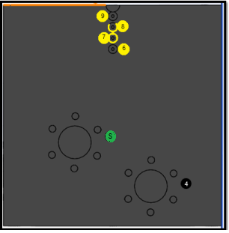

This is where the steam inlet valve will get placed

This is where the pressure sensor will get placed

This is where the RTDs will get placed

*Figure 4 Top view of the condensation chamber*

Figure 5 below shows a cross sectional view of the condensation chamber where we can see a cavity for the copper block, RTDs holes and the type of screw holes we have used.

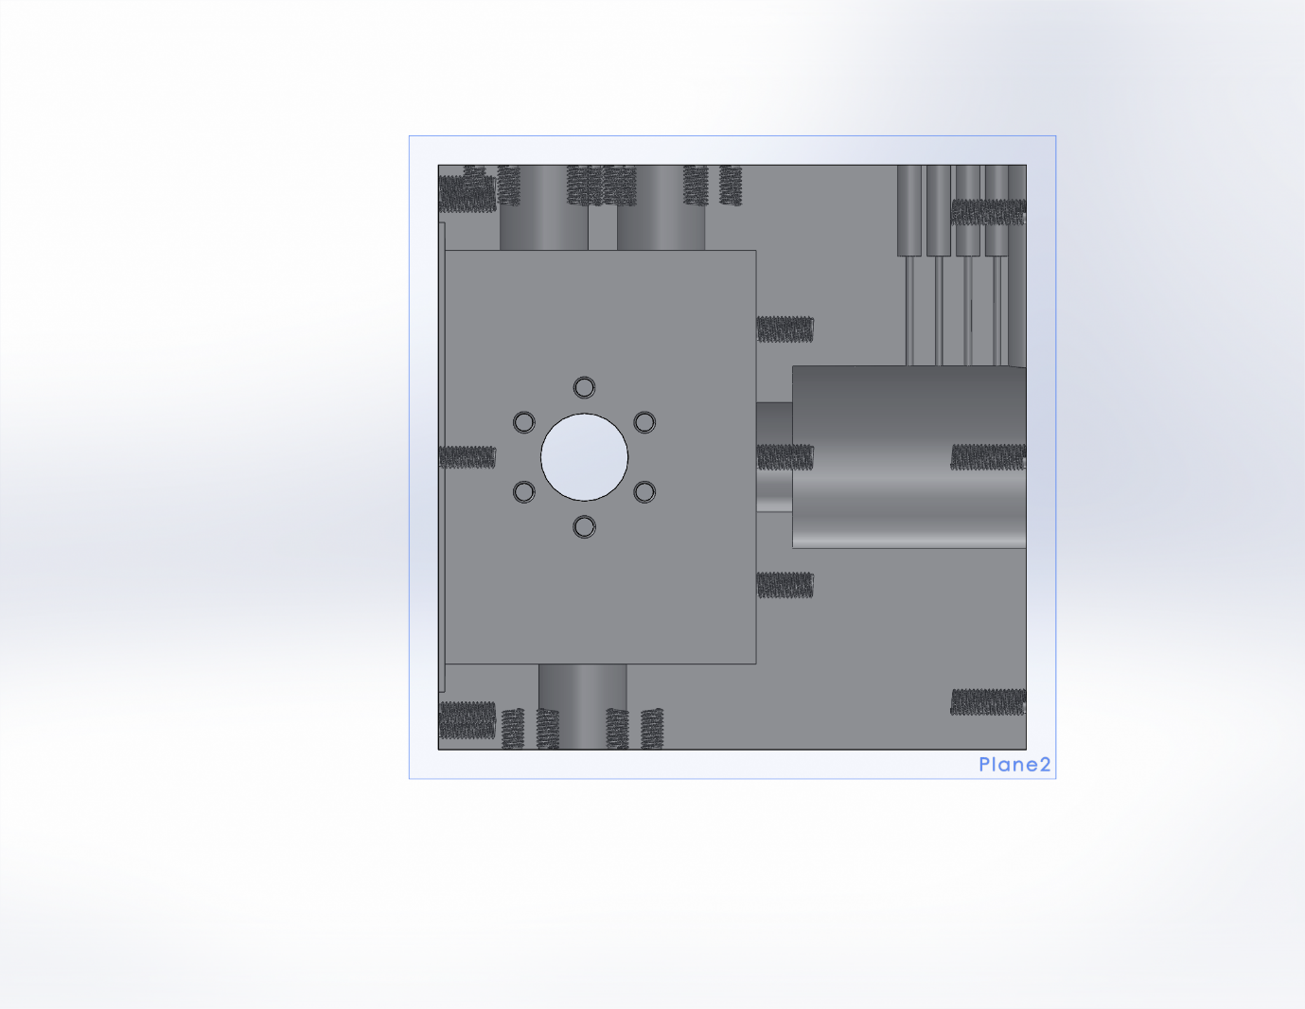

M6 screw holes

Copper block space

M5 Screw holes to join circular clamp

RTDs Hole 6,7,8,9

M5 screw hole

*Figure 5 Cross-sectional view of condensation chamber*

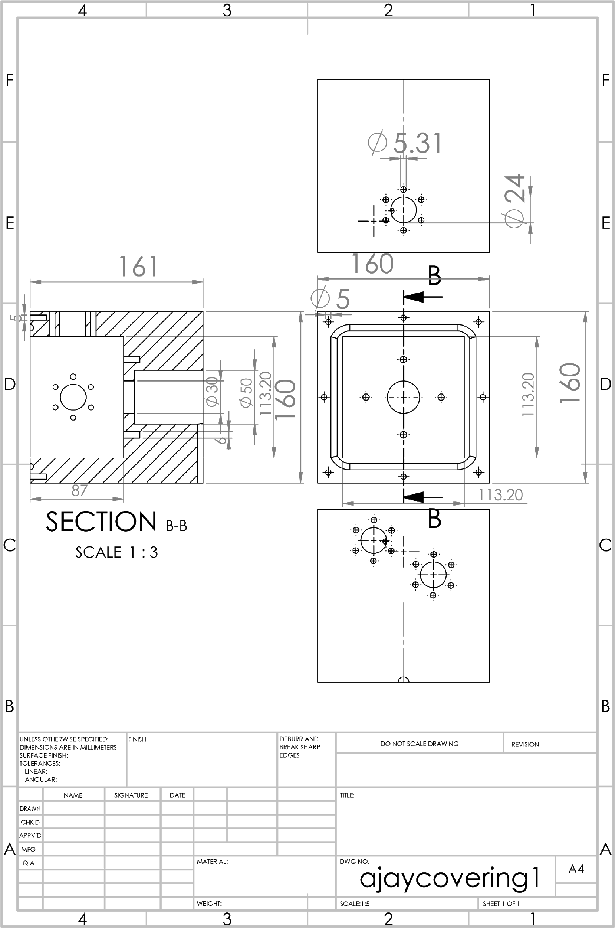

*Figure 6 Engineering Drawing of PTFE Block*

### Dimensioning of the Teflon block

The dimension of the Teflon block is shown in the above engineering drawing Figure 7. All dimensions for figure 7 and thereafter are done in millimetres(mm).

### Copper Block

We chose copper block as our unidirectional heat transfer device due to its high thermal conductivity and relatively cheap cost as compared to other materials.

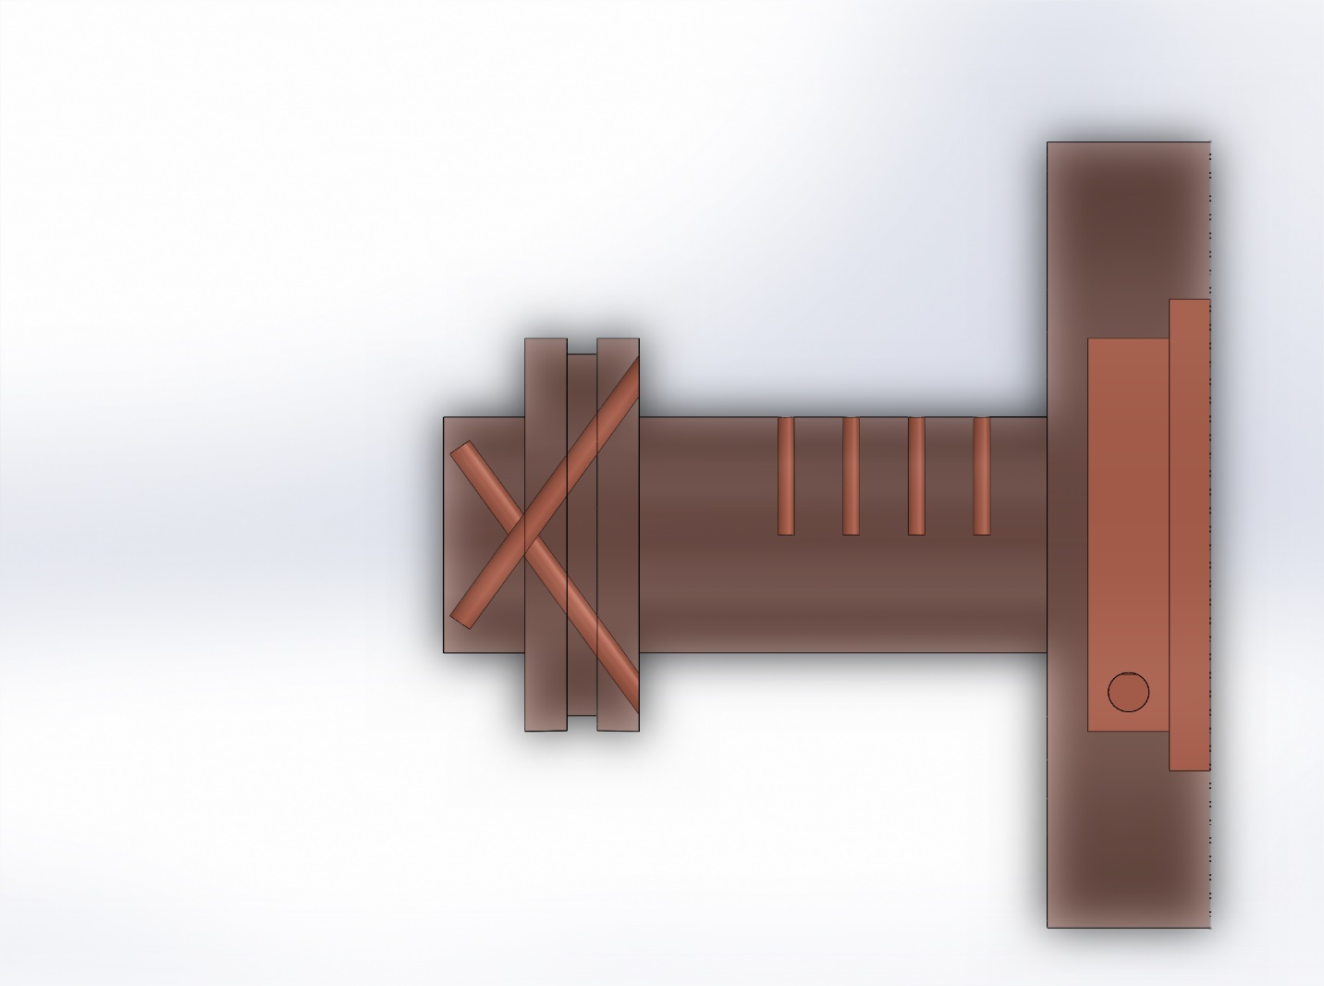

Slant holes to measure the surface temperature

RTDs hole

(a)Substrate position

(b)O ring spacing

*Figure 7 Cross-sectional view of copper block*

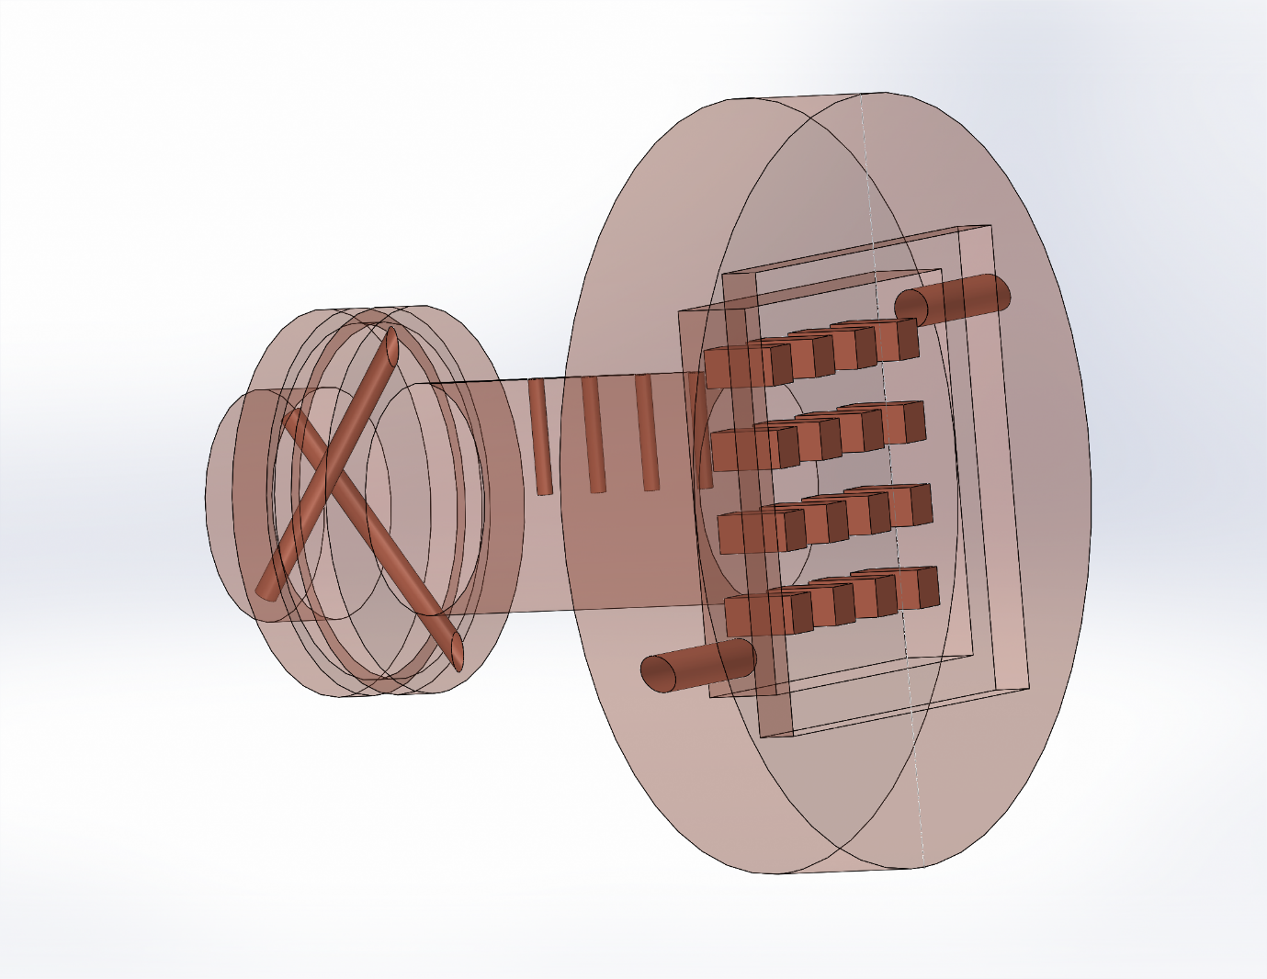

(d)Fins to increase the surface area

(c) Holes for coolant inlet

Figure 8 Transparent view of the copper block showing fins

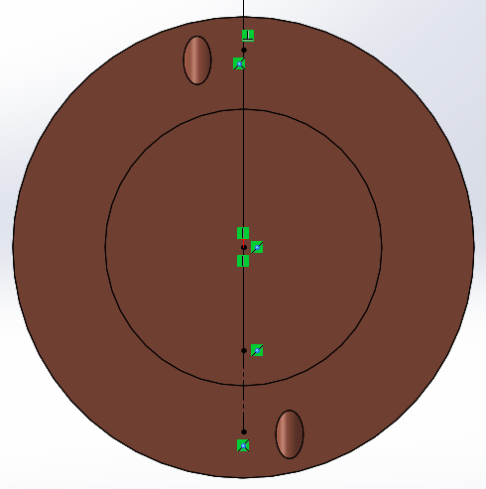

RTD hole to measure the surface temperature 4

RTD hole to measure the surface temperature 5

*Figure 9 cross-sectional view showing slant hole*

The condensation substrate will be clamped at the front side of the copper block (i.e. position(a)) shown in Figure 8 and we need the condensation chamber to be leak proof so we made a groove (b) in Figure 8 in which there will be an O-ring to ensure that there will be no leakage. (c) in the Figure 9 is the coolant inlet and (d) in Figure 9 are the fins added to increase the surface area to increase the heat transfer.

Initially we made a design with only one slant hole at 300 but due to some machining constraint we changed the design and made 2 holes at 550 (refer figure 11 below) for inserting thermocouples. (to measure average the surface temperature of the substrate).

When the actual machining was performed, we used a drill bit of 2mm width. But it broke down and got stuck in the copper block and we extracted the drill bit using EDM. So, we made holes of 3mm. We also increased the distance between the blind end of the holes and copper surface to 3mm from the initial 2mm to increase the margin of safety (figure 11). The remaining machining was done as shown in the engineering drawings below.

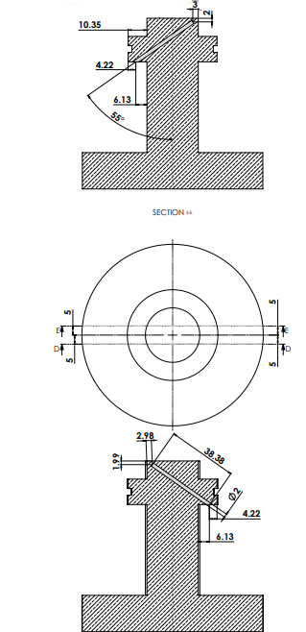

Modified slant hole diameter is 3.00mm

Modified distance from the surface is 3.15mm

*Figure 10 Engineering Drawing of slant hole in Copper block*

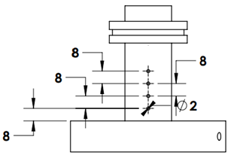

Figure 11 Top view of the copper block

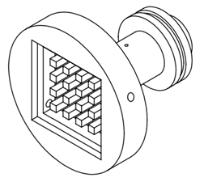

Figure 12 Isometric view of the copper block

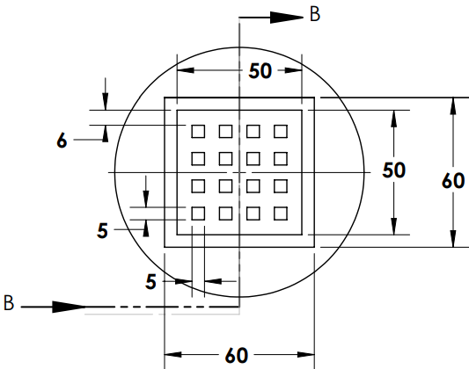

Figure 13 Back view of the copper block

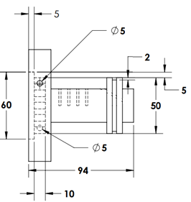

Figure 14 Side view of the copper block

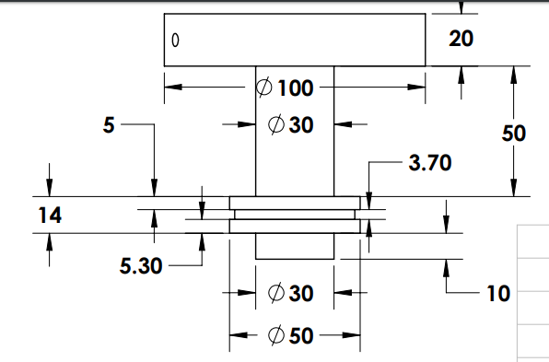

*Figure 15 Engineering Drawing Copper block*

### Copper block dimensioning

For dimensioning of the copper block, you can refer Figure 11, 12, 13, 14, 15, 16. We have done the dimensioning of the slant hole of copper block in Figure 11, in Figure 12 we have shown RTDs’ hole dimensions. Figure 13 is the isometric view of the copper block; in Figure 14 we have shown the dimensions of the back side of the copper block.

### Circular clamp

The material we have used to make this clamp is TEFLON (PTFE), the same material that we used for the condensation chamber to ensure that condensation won’t happen over the clamp. The periphery of the hole is made a little slant so that condensate won’t accumulate. The holes which will connect this circular clamp to the condensation chamber are of M5.

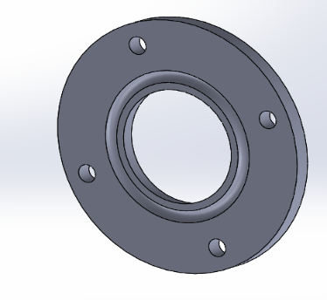

periphery of the hole is little slant so that condensate won’t settle on the circular ring and hinder the condensation process

*Figure 16 Circular clamp (Solid works screenshot)*

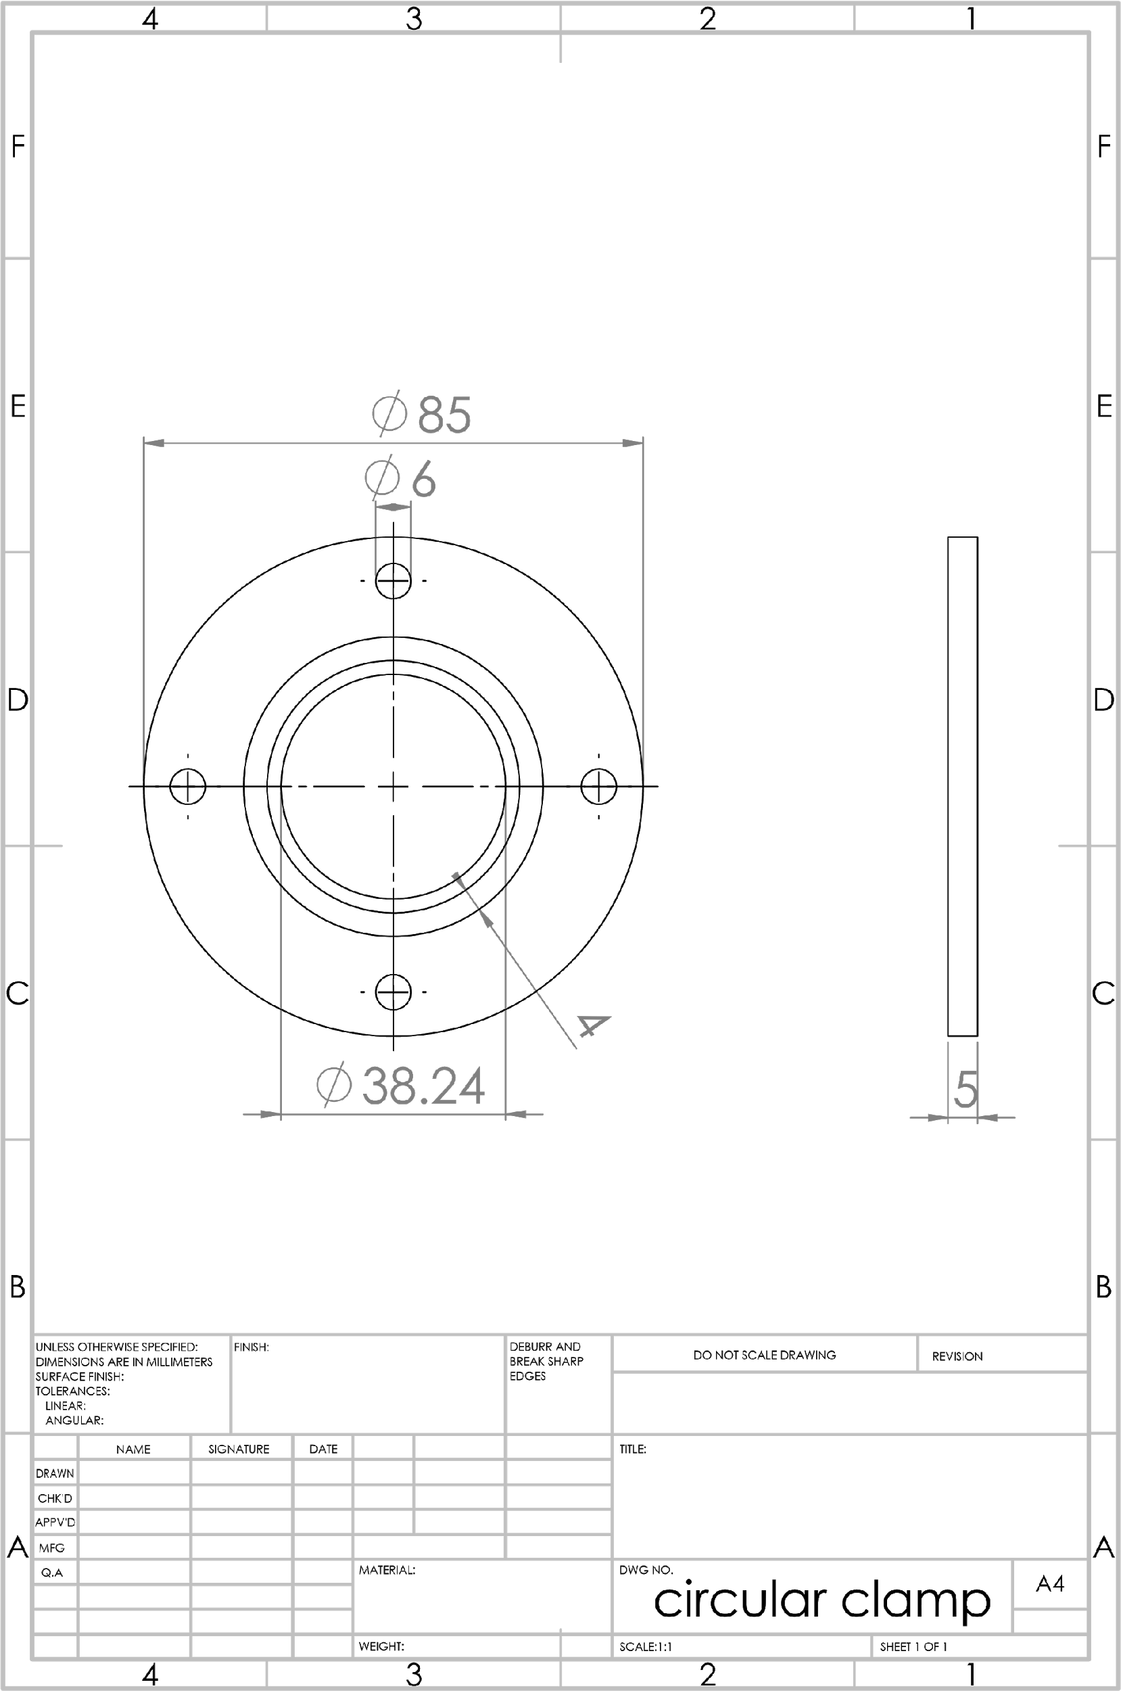

*Figure 17 Engineering Drawing of clamp*

### Dimensioning of Circular ring

The dimension of the circular ring is shown in the above engineering drawing Figure 18.

### Plexiglass (front cover)

It will be a transparent sheet so that we can see and record the experiment. And the holes which will connect this plexiglass with the condensation chamber are M5 holes.

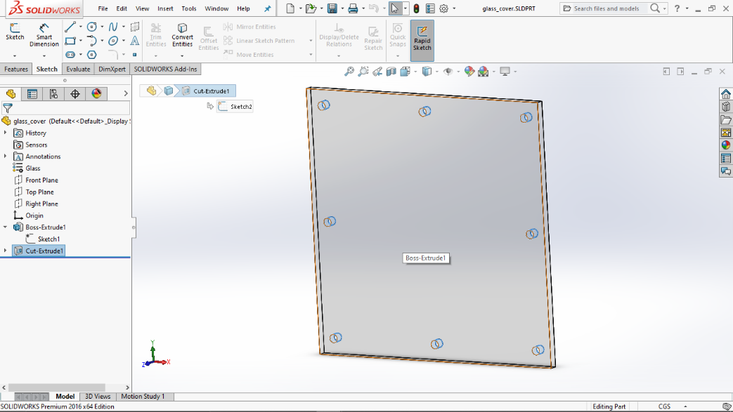

*Figure 18 Front glass (Solid works screenshot)*

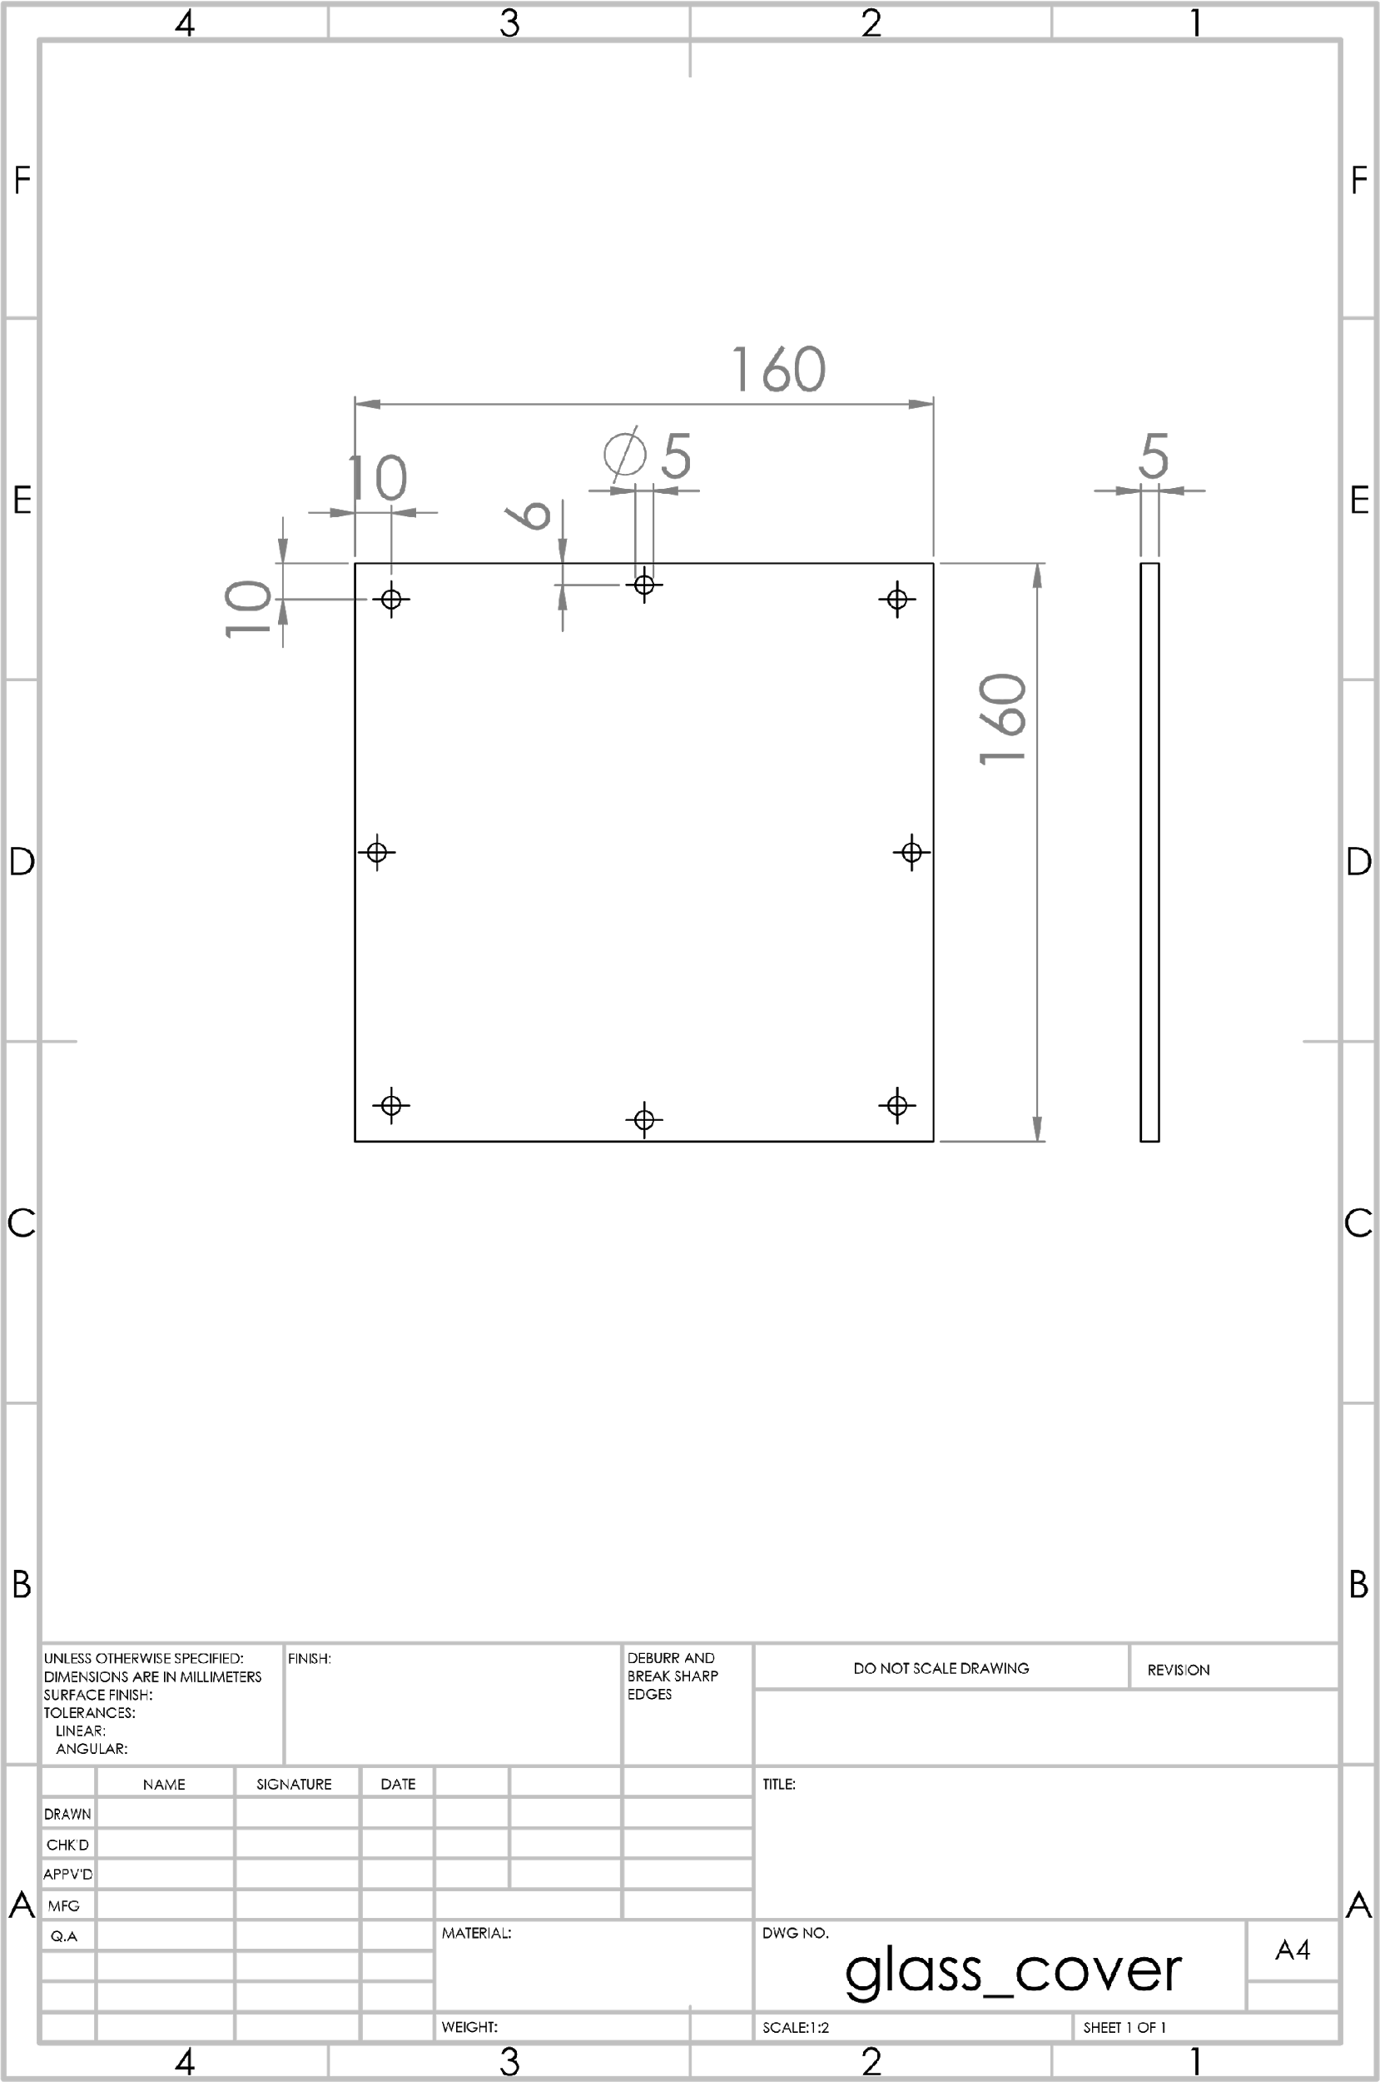

*Figure 19 Engineering Drawing of PlexiGlass*

### Dimension of Plexi Glass

The dimension of the plexi glass is shown in the above engineering drawing Figure 20.

### Back cover

It is also made up of PTFE material same as the condensation chamber and circular clamp to ensure that there will be no leakage of heat and coolant from the back. Holes which will join the condensation chamber are M6 and holes from where the coolant will flow in are M5.

We need 2 suitable connectors for the coolant inlet and outlet.

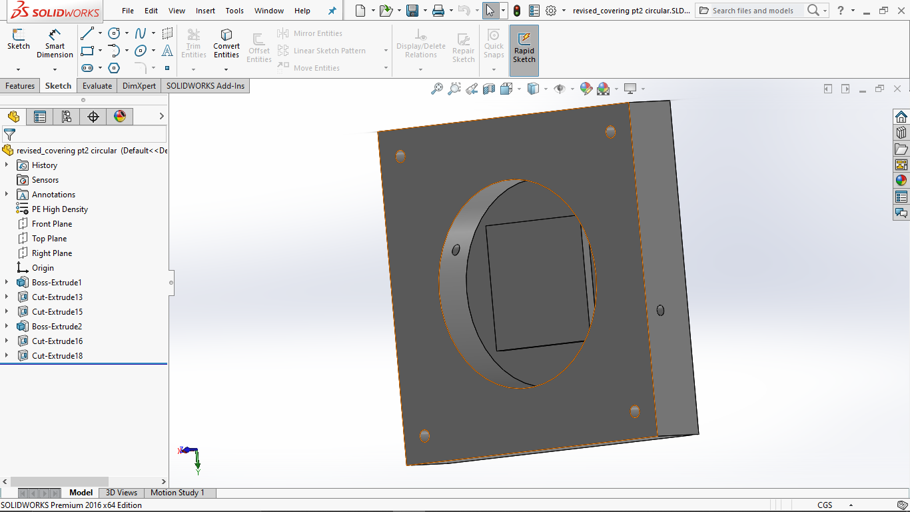

Coolant outlet

Coolant inlet

*Figure 20 Back closing cover (Solidworks screenshot)*

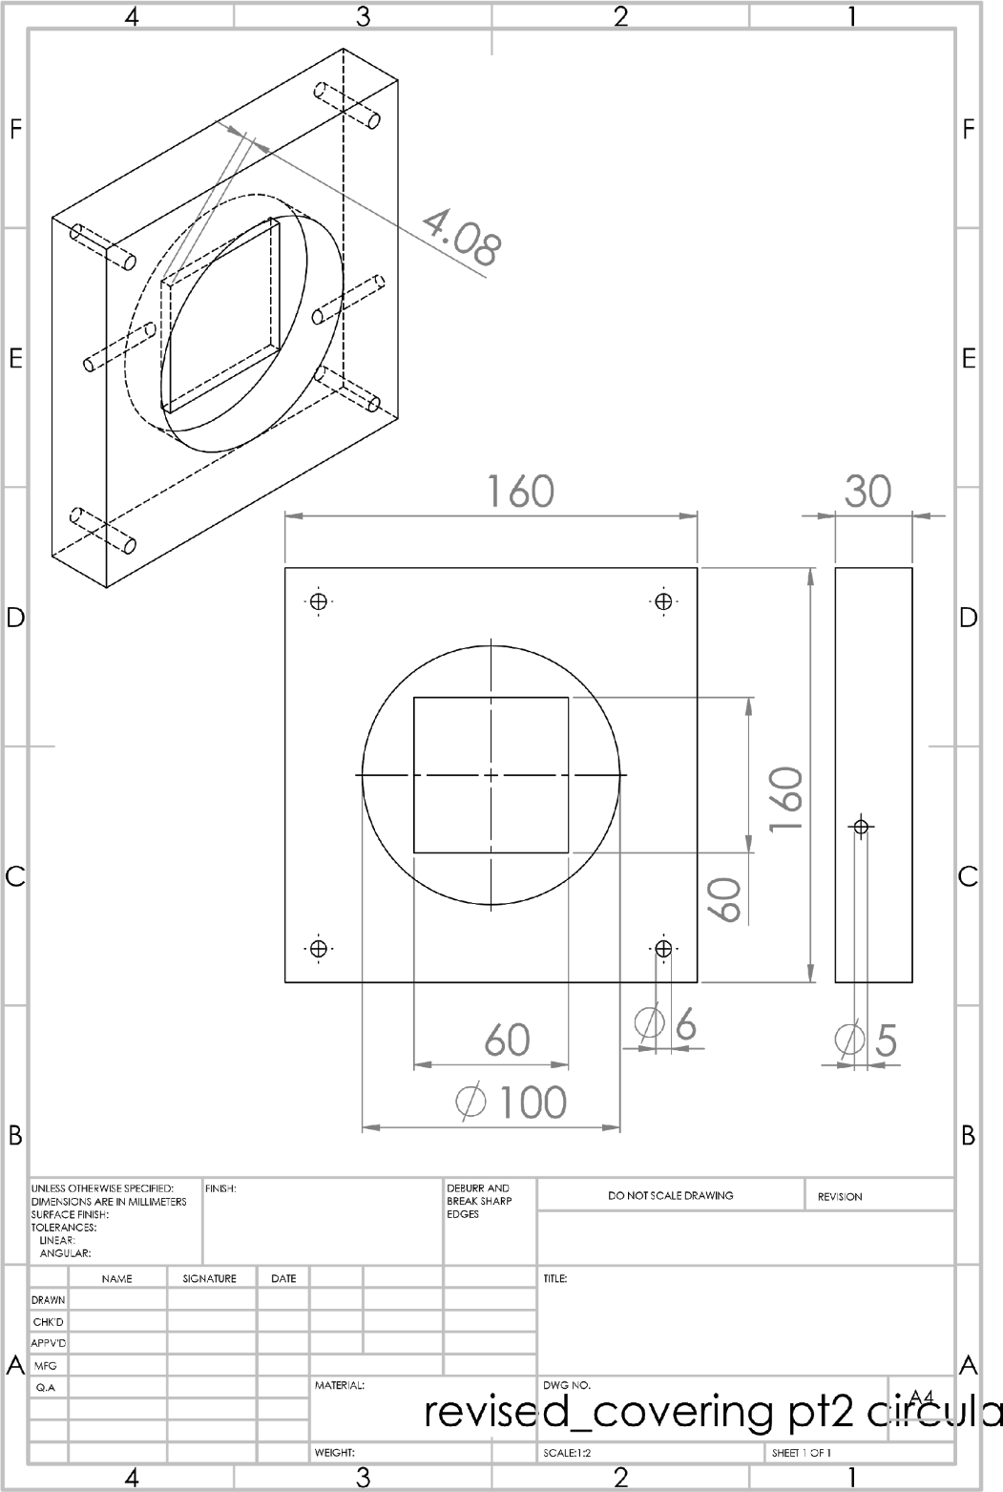

*Figure 21 Engineering Drawing of Back cover*

### Dimension of Back cover

The dimensions of the back cover are shown in the above Figure 22.

### Stand

A stand is made to support the condensation chamber. It will join condensation chamber to bread board. It is made up of cast iron material. And the drilled holes are of M6. The upper part will get joined to the black cover and the lower part will get joined to the bread board. the Upper part was bought from the shop and lower part from our work shop and welded together.

The stand will be coated with rust oleum primer and paint.

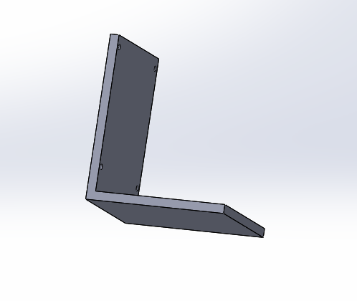

Lower part will get joined to the bread board

Upper part will get joined to the back cover

*Figure 22 Stand (Solidworks screenshot)*

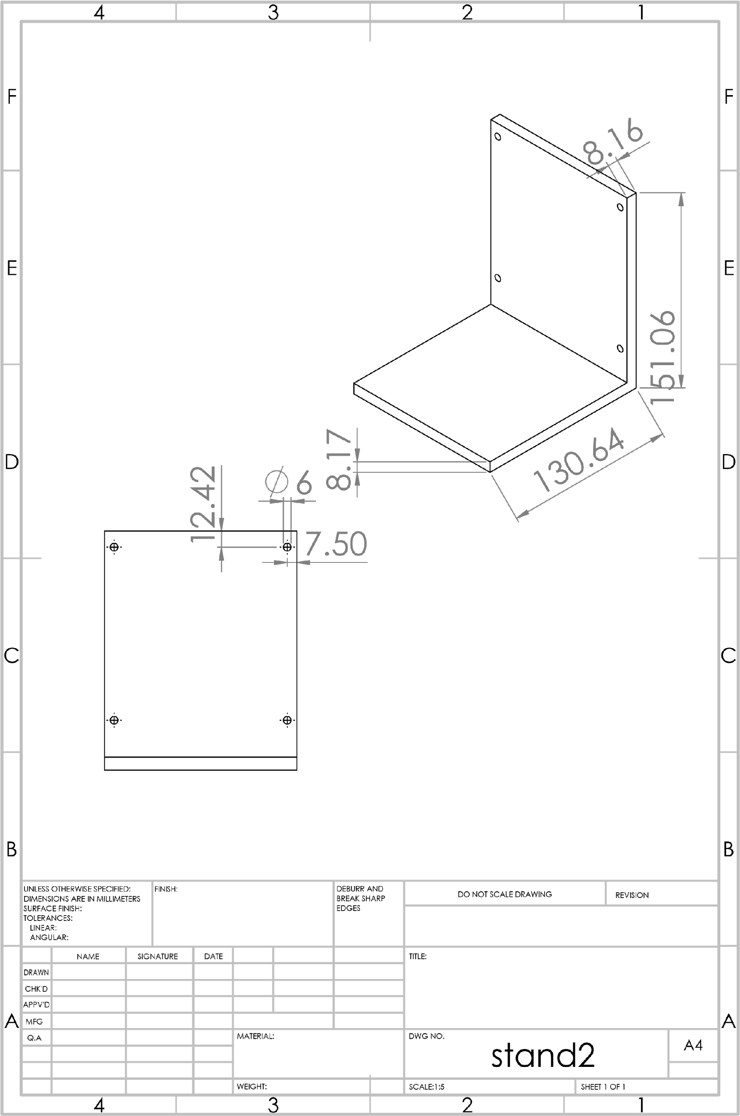

*Figure 23 Engineering Drawing of Stand*

### O-rings

All the O-ring that we have used are made up of nylon material. The quality of that material is that it can withstand at high temperature and the corrosion of this material is very slow. All the related information is given below at the purchasing section.

### Model

Shown below is the assembly of the condensation chamber with accessories attached. All the components are attached with bulkhead clamps to the chamber. On the top left a steam inlet and top right a low-pressure sensor is attached. On the left side of the chamber another high pressure sensor is mounted via a 90° elbow. On the right side an electrical feedthrough is in used for inserting thermocouples into the chamber for measuring the steam temperature. On the bottom a Tee is attached where one side opens up to the vacuum pump and the other to the water drain. Shown below is the assembly of the condensation chamber in different views Figure 25 shows the front view of the condensation chamber, Figure 26 shows the side view of the condensation chamber, Figure 27 show the side exploded view of the condensation chamber, Figure 28 shows the front side the condensation chamber, Figure 28 shows the isometric of the condensation chamber.

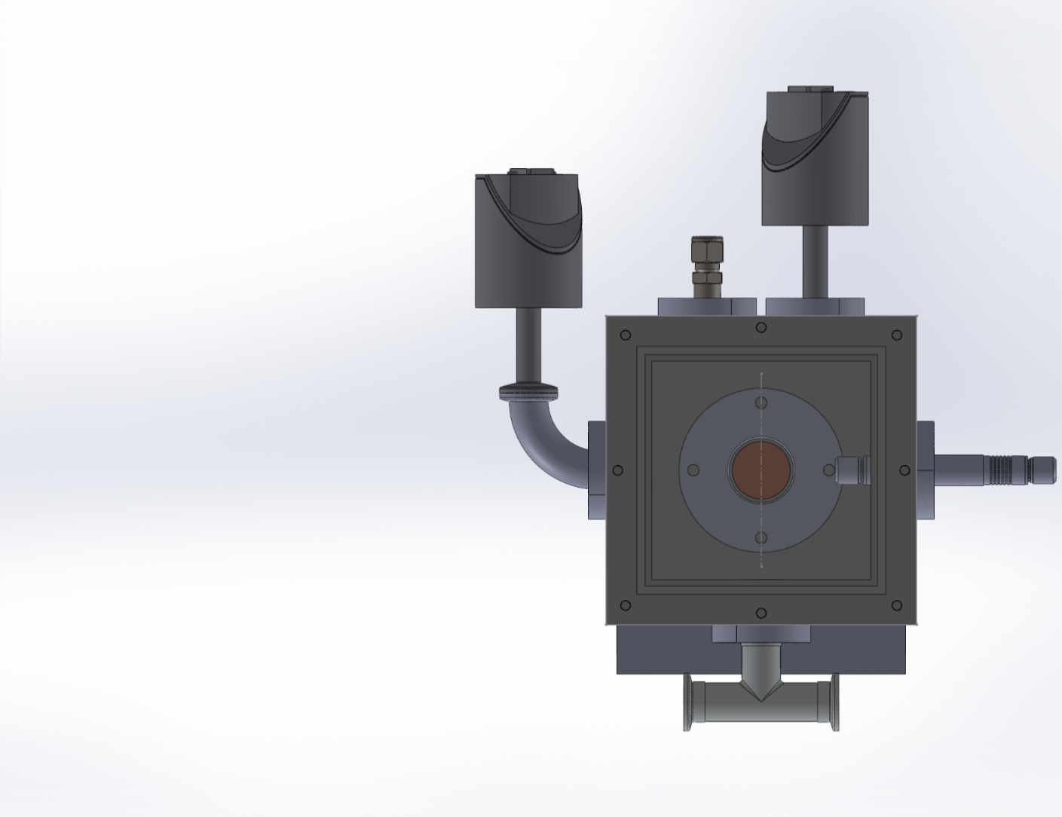

This is where the sample will get attach

Vacuum Feedthrough F

Steam inlet valve S

Pressure sensor 4

Pressure sensor 3

*Figure 24 front view of condensation chamber (Solidworks screenshot)*

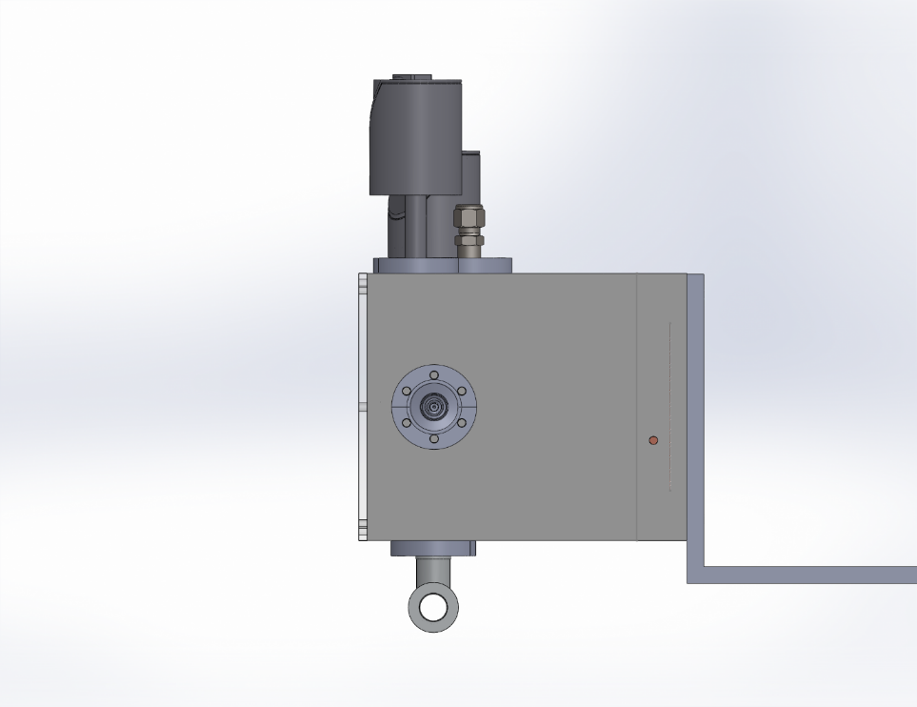

*Figure 25 Side view of condensation chamber*

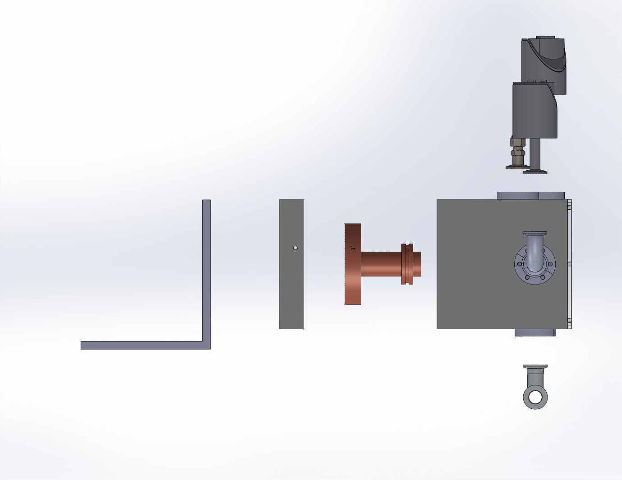

Stand

Back Plate

Copper block

Figure 26 Side exploded view of the chamber

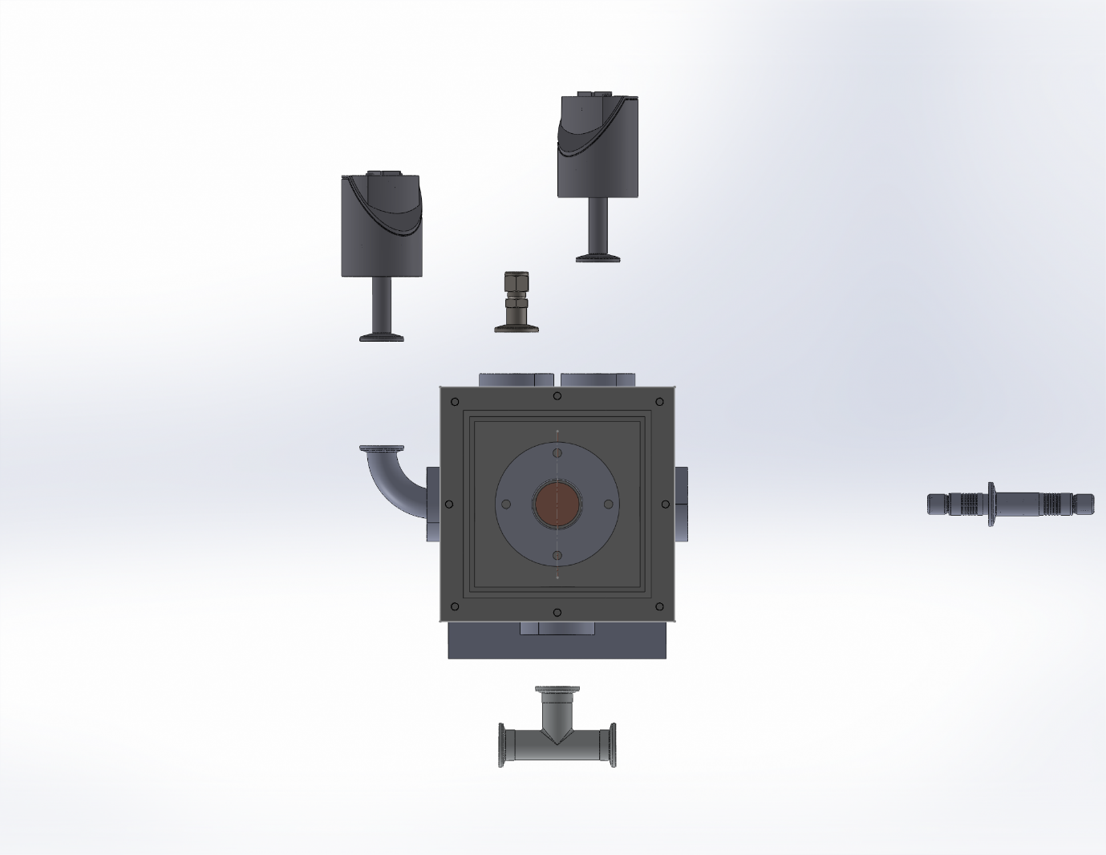

Figure 27 Front Exploded view of the condensation chamber

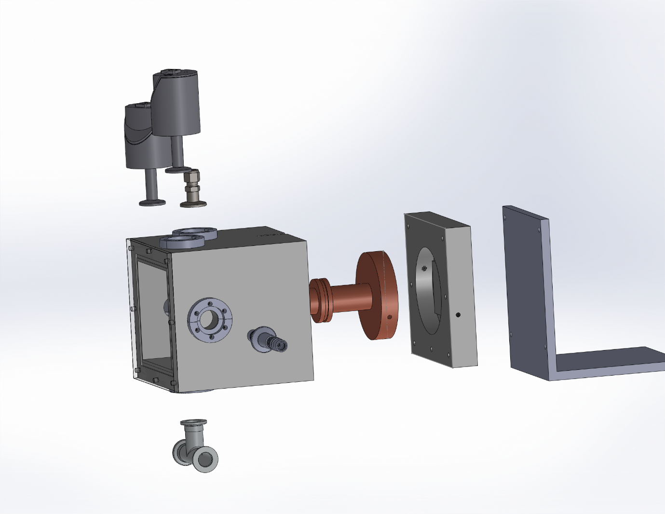

*Figure 28 Isometric Exploded view of chamber*

# Products used

*Table 2 List of Product used*

|  |  |  |  |  |
| --- | --- | --- | --- | --- |
| **Sr. No.** | **Part** | **Product No.** | **quantity** | **supplier** |
| 1 | Boiler | - | 1 | Finite Technologies |
| 2 | Connecting pipes | SS-T6M-S-1.0M-6ME | 6pcs (1m each) | Swagelok |
| 3 | Pressure reduction valve (bellow valve) | SS-6BMW-MM | 1 | Swagelok |
| 4 | Elbow 90° | SS-6M0-9 | 4 | Swagelok |
| 5 | Condensation chamber | - | 1 | CTR Ludhiana |
| 6 | PTFE block | - | 1 | CTR Ludhiana |
| 7 | Copper block | - | 1 | CTR Ludhiana |
| 8 | Clamp | - | 1 | CTR Ludhiana |
| 9 | O-ring for copper block | HSN No-40169320 | 1 set | Polymax India |
| 10 | O-ring for clamp | HSN No- 40169320 | 1 set | Polymax India |
| 11 | O-ring for plexiglass | HSN No- 40169320 | 1 set | Polymax India |
| 12 | Plexiglass front cover | - | 1 | CTR Ludhiana |
| 13 | Plexiglass heater (film heater) | - | 1 | Watt Heat Technology (India Mart) |
| 14 | Bulkhead clamp with connecting screws | 211-541 | 5 | Inficon |
| 15 | Electrical feedthrough with inner & outer connector | 214-113, 214-191,  214-172 | 1 each | Inficon |
| 16 | Swagelok adapter | 120ASW016-6 | 1 | Pfeiffer vacuum |
| 17 | Elbow | 120RRB016-90 | 1 | Pfeiffer vacuum |
| 18 | Centering Ring, | 122ZRG016 | 11 | Pfeiffer vacuum |
| 19 | Clamping Ring, | 120BSR016 | 11 | Pfeiffer vacuum |
| 20 | Back cover | - | 1 | CTR Ludhiana |
| 21 | Tee | 120RTS016 | 1 | Pfeiffer vacuum |
| 22 | Screws M5 and M6 |  | 30 pieces  each | ME workshop |
| 23 | Chiller pipe connector |  | 2 | Anand |
| 24 | Stand | - | 1 | ME workshop |
| 26 | Chiller | CW-30CP | 1 | Bandi Technology |
| 27 | Vacuum pump and Accessories | 01FD-020I216 | 1 | HHV Pumps |
| 28 | Ball valves | 120VKZ016 | 2 | Pfeiffer vacuum |
| 29 | Connecting hoses | 120SWN016-0250 | 3 | Pfeiffer vacuum |
| 30 | Insulation for pipe |  | 1 |  |
| 31 | RTDs | QUOTATION No. 1AN19080292 | 5 | Thermo Sensor GmbH |
| 32 | Thermocouples | 5SRTC-GG-T-20-22 |  | Omega |
| 33 | Pressure Sensor (TPR 270 Active Pirani Gauge) & Accessories | PT R26 780 | 1 | Pfeiffer Vacuum |
| 34 | Vacuum gauge CMR 362& Accessories | PT R24 611 | 1 | Pfeiffer Vacuum |
| 35 | Rust metal primer and paint |  | 1 | Rust Oleum |
| 36 | Heating Tape | Quotation No. DKQ-750 | 1 | D.K. Scientific Industries |

**Working**

Water will be pumped into the boiler and drained out via a drainage valve 3 initially to make sure there is no trapped air inside the boiler. We will repeat this a number of times to make sure no there is no trapped air inside. Then we will shut off the drainage valve 3 and turn ON the boiler and drain some steam too, via another steam drain valve to ensure there is no air transfer to our condensation chamber (Note: - presence of non-condensable decrease heat transfer very significantly as they form a barrier between the substrate and the water vapours and reduce heat transfer, so it will not matter whether we are using drop wise or film wise condensation if non-condensable gases are present). During this process the pressure reduction valve 4 will be closed. Simultaneously inside the condensation chamber the vacuum pump v will create a vacuum to remove any trapped gas inside as it can hinder in the condensation heat transfer.

Then the drainage valve 3 will be closed and the pressure reduction valve (bellow valve) 4 will be opened. The bellow valve 4 will be used to regulate the pressure of the steam and send it to the condensation chamber via an inlet S to the chamber.

In condensation chamber steam will condense on substrates (prepared for drop wise condensation and film wise condensation in separate cases) and then after condensate will drain out. Two pressure sensors 3 and 4 will be mounted as shown in the diagram below to measure the pressure inside the chamber in the low and high pressure ranges respectively. Electric feedthrough F will be used on one side for inlet of thermocouple to be used in the measurement of steam temperature inside the chamber.

Condensation will take place on the surface of the substrate attached to the copper block with a clamp. Galinstan interface will be sandwiched between the copper block and the substrate ensuring the contact resistance is minimized. As the saturated steam condenses on the substrate, the RTDs inserted into the copper block will be used to measure the temperatures at various locations and this data will be used to make the calculations of the heat flux through the substrate. At the back side of the copper block coolant will flow past the fins absorbing heat from the copper block.

After the steam condenses it will make its way out through the t-type outlet attached at the bottom of the chamber. One way will lead to the vacuum pump v via a ball valve 5 and other to drain tank via the drainage valve. 6

# **Steam Thermodynamics**

Steam coming out of the boiler is saturated at 1atm 1000C. In the throttle valve, it undergoes a throttling process. In throttling process enthalpy of initial state and final state will remains the same which is h1=2675.43KJ/kg. The process is adiabatic and there is no work done. Change in potential energy is very small and though the exit velocity is higher than inlet velocity, change in kinetic energy is insignificant. Thus, the energy conservation equation becomes:

h1 + gz + v12/2 = h2 + gz + v22/2

h1 = h2 + v22/2

h1=h2; which is equivalent to:

h – enthalpy per unit mass

v- velocity of steam

1-initial state

2-final state

V- specific volume

u – Internal energy per unit mass

As the flow energy increases (p2v2> p1v1) in the process by using u1 +p1V1 = u2 + p2V2, this causes a reduction in the internal energy (u2<u1) resulting in reduction in temperature. But still at 50mbar water vapour will be at superheated state [7].

# **References**

1. "Thermodynamics: An Engineering Approach - Amazon.com." <https://www.amazon.com/Thermodynamics-Engineering-Yunus-Cengel-Dr/dp/0073398179>. Accessed 2 May. 2020.
2. <https://www.ijser.org/researchpaper/Dropwise-and-filmwise-condensation.pdf>
3. "Wetting - MIT." [http://web.mit.edu/nnf/education/wettability/wetting.html. Accessed 2 May. 2020](http://web.mit.edu/nnf/education/wettability/wetting.html.%20Accessed%202%20May.%202020).

<https://www.researchgate.net/publication/46401679_Silica_Aerogel_Synthesis_and_Applications>

1. *National Nanotechnology Infrastructure Network*, www.nnin.org/education-training/k-12-teachers/nanotechnology-curriculum-materials/water-race-hydrophobic-0. Accessed on:
2. Paxson, Adam. “Condensation heat transfer on nanoengineered surfaces”. Master’s thesis. Massachusetts Institute of Technology, Massachusetts, USA. 2011.
3. Emmerich, Theo. “Design of an experimental setup for the observation of condensation at low pressure”. Semester Project. ETH Zurich, Zurich, Switzerland. 2016
4. http://procurefast.com/index.php/plastic-sheets/ptfe-rigid-thick-sheets-detail